European clothing production sector is doing well, near-shoring gains traction
There is a notable shift going on in the fashion industry: a surge of European brands is having their clothing manufactured closer to home, instead of overseas. Near-shoring they call it, and with demands for more sustainable production, rising prices across the globe and Europe being a vibrant textile hub the return to local sourcing is no surprise. Manufy, a platform that connects brands and sustainable manufacturers from Europe, sees the newfound interest for near-shoring in their rapidly growing user base.

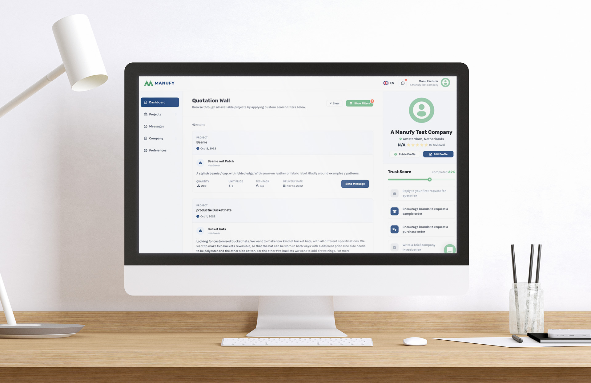

A wave of change
For many years, European manufacturers had hard times competing with overseas production parties. Platforms like Alibaba made it very easy for European brands to find production partners from abroad, often manufacturing products at a fraction of the price. Manufacturers from Europe were mostly dependent on trade shows to get new business, did not have much of an online presence and couldn’t compete on price.
This, however, changed when the pandemic hit. Transport costs shot through the roof, prices of raw materials rose and a new wave of awareness for sustainable clothing led to more and more brands searching for alternatives closer by. The fact that most trade shows were canceled due to lockdowns pushed both manufacturers and brands to online solutions. That’s where Manufy came in. A fully European marketplace for sustainable fashion production that helps both parties find each other in the digital space.
Matching brands & manufacturers
Since its inception in December of 2020, Manufy has seen their user base grow with rapid speed. On the platform brands get to upload their projects, specifying what exactly needs to be made. Manufacturers that are suited for the job can in turn place offers on those projects. When there’s a match, both parties come together in a chat where they can start talking about the project in more detail.
Global events in combination with customers becoming more conscious about the products they buy have resulted in brands changing the way their fashion is being produced. With reaching out to European manufacturers becoming a lot easier, there seems to be more brands that shift their production to Europa. This is something the Manufy team also sees in their data, with the amount of projects posted on Manufy greatly increasing over the last months.

Over: Manufy
Manufy launched in 2020 after a group of Dutch entrepreneurs saw there was a lack of online representation of sustainable manufacturers. Manufy aims to connect brands and manufacturers in an efficient, transparent and - most importantly - sustainable way. As of now the platform is host to more than 5500 brands and 1200 manufacturers.

Newsroom
Bekijk het volledige persbericht inclusief meer foto's en video's in onze Newsroom.
Bekijk het volledige persbericht
Bekijk alle voorgaande persberichten

Contact informatie
Naam: Michiel Dicker
E-mail: michiel@manufy.com
Telefoon: 0621715581

